Experiment -7

AIM

Design Tm to perform addition of the following w= aa+ aaaa

After addition = aaaaaa

PROCEDURE

1. Start the automata
2. Enter the states
3. Connect the respective nodes (states) and self loop.
4. Enter the inputs values in the named nodes .
5. Compile the execution with suitable inputs
6. Stop the executions.

Design input:

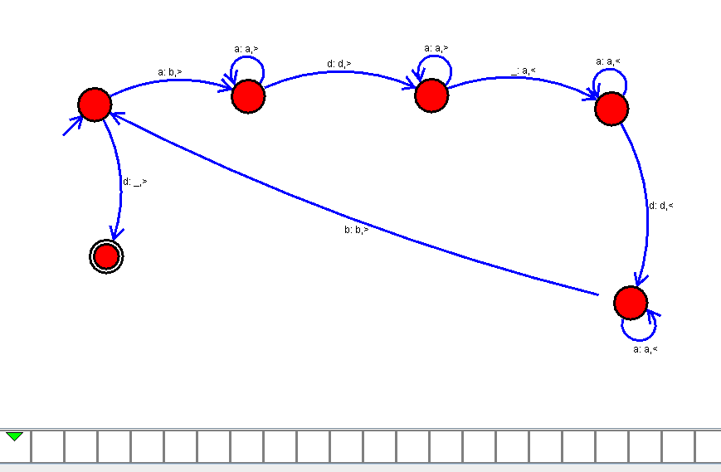

OUTPUT :

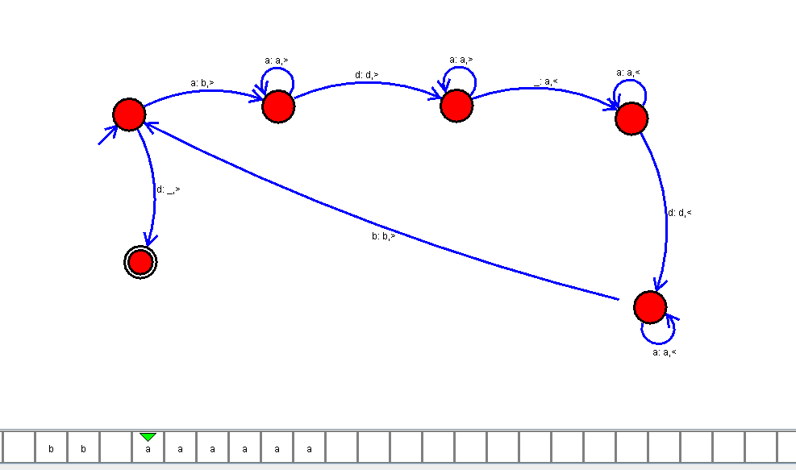

RESULT:

Thus the design of TM to perform addition has been executed and implemented successfully.